**Table Name:** employee

|  |  |  |  |  |  |
| --- | --- | --- | --- | --- | --- |
| **id** | **first_name** | **last_name** | **salary** | **dept_id** | **role** |
| 1 | Rahul | Sharma | 45000 | 1 | IT_PROG |
| 2 | Pratik | Gajne | 67000 | 2 | ML_ENGG |
| 3 | Naresh | Bhatt | 48000 | 1 | IT_PROG |
| 4 | Nisha | Shetty | 65000 | 1 | IT_PROG |
| 5 | Vishal | Kumar | 56000 | 2 | TESTER |
| 6 | Niranjan | Pandey | 43000 | 1 | IT_PROG |
| 7 | Simran | Mehta | 56000 | 1 | SUPPORT |
| 8 | Vipul | Shekhawat | 67000 | 2 | SUPPORT |
| 9 | Binay | Gosh | 32000 | 1 | IT_PROG |
| 10 | Nitin | Rao | 54000 | 2 | TESTER |

**Table Name: Department**

|  |  |
| --- | --- |
| **id** | **dept_name** |
| 1 | IT |
| 2 | CS |

1. Write a sql query to create view named as EmployeeView for those employee with role as "IT_PROG". EmployeeView. contains id, first_name, last_name,role.

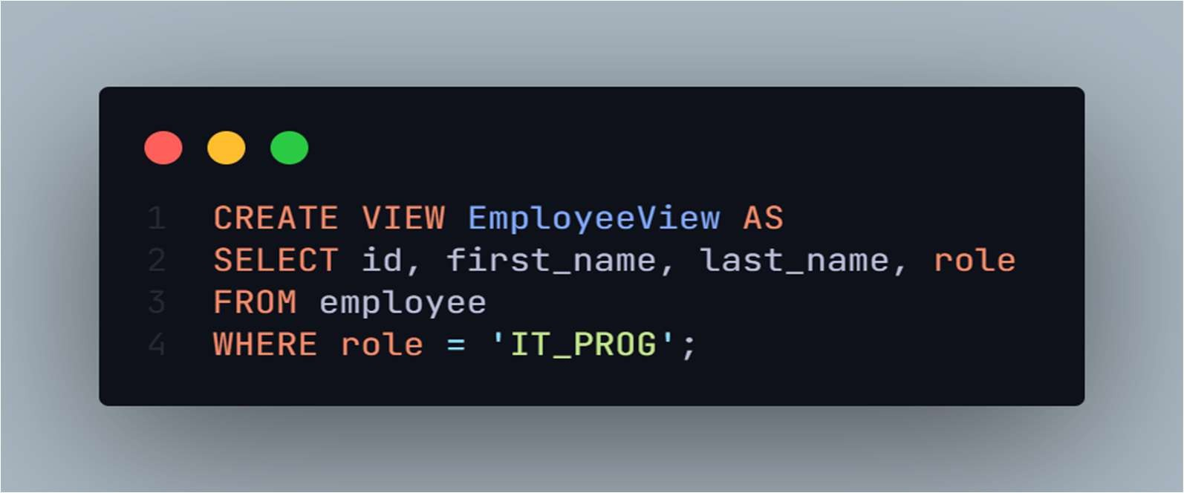

1. Write a sql query to insert a new a new record in the EmployeeView as shown below. Record to be inserted

|  |  |  |  |  |  |
| --- | --- | --- | --- | --- | --- |
| **id** | **first_name** | **last_name** | **salary** | **dept_id** | **role** |
| 11 | Piyush | Bansal | 52000 | 2 | Data Analyst |

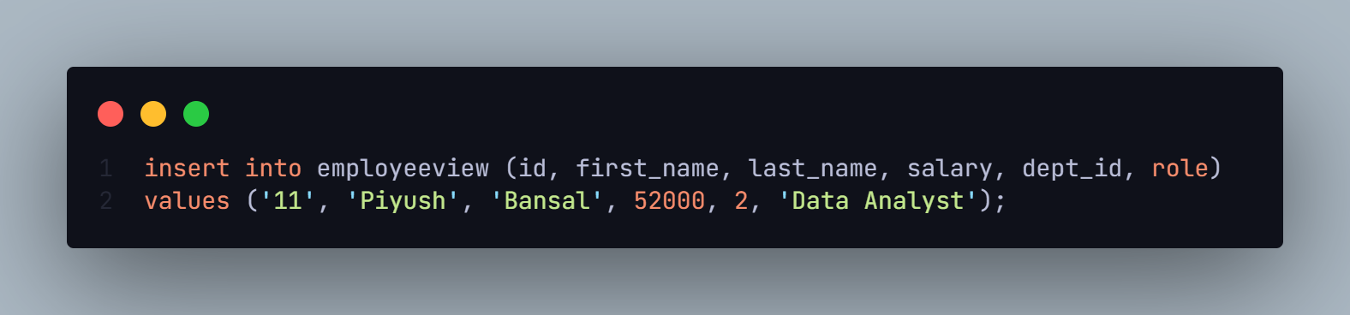

1. Write a sql query to change the role of all employee from EmployeeView from "IT_PROG" to "IT_PROGRAMMER".

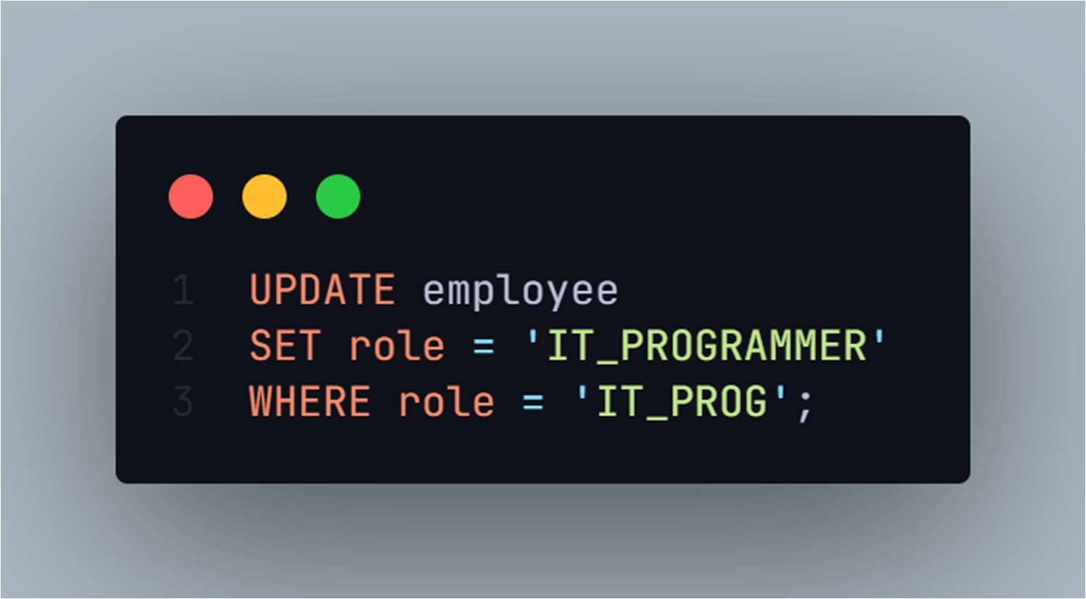

1. Write a query to delete a employee from EmployeeView with id=5.

